**PROJECT REPORT ON**

“Introduction to Virtualization with VirtualBox ”

# Submitted By:

Ananya Sharma, UID- 24MCA20024

# Under The Guidance of:

Mrs. Geetanjali Sharma



# CERTIFICATE

This is to certify that Ananya Sharma (UID- 24MCA20024) have successfully completed the project title “Introduction to Virtualization with VirtualBox in Linux” at University Institute of Computing under my supervision and guidance in the fulfilment of requirements of first semester, Master of Computer Application- Specialization in General. Of Chandigarh University, Mohali, Punjab.

Dr. Abdullah Mrs. Geetanjali Sharma

Head of the Department Project Guide Supervisor University Institute of Computing University Institute of Computing

# ACKNOWLEDGEMENT

We deem it a pleasure to acknowledge our sense of gratitude to our project guide Mrs. Geetanjali Sharma under whom we have carried out the project work. His incisive and objective guidance and timely advice encouraged us with constant flow of energy to continue the work.

We wish to reciprocate in full measure the kindness shown by Dr. Abdullah (H.O.D, University Institute of Computing) who inspired us with his valuable suggestions in successfully completing the project work.

We shall remain grateful to Dr. Manisha Malhotra, Additional Director, University Institute of Technology, for providing us a strong academic atmosphere by enforcing strict discipline to do the project work with utmost concentration and dedication.

Finally, we must say that no height is ever achieved without some sacrifices made at some end and it is here where we owe our special debt to our parents and our friends for showing their generous love and care throughout the entire period of time.

Date: 24.10.2024

Place: Chandigarh University, Mohali, Punjab

Ananya Sharma

UID- 24MCA20024

## ABSTRACT

Virtualization is a critical technology in modern computing, enabling multiple operating systems (OS) to run simultaneously on a single hardware platform. This project, "Introduction to Virtualization with VirtualBox in Linux," explores the implementation and significance of virtualization using VirtualBox, an open-source, cross-platform virtualization software developed by Oracle. The focus of this project is on deploying Linux- based systems within VirtualBox to understand how virtualization functions and its applications in both development and testing environments.

The primary objective of this project is to demonstrate the process of setting up and configuring VirtualBox on a host machine, installing a Linux-based guest operating system (Kali Linux), and exploring its capabilities. The project outlines the steps required to create virtual environments, manage resources efficiently, and enable seamless interaction between the host and guest OS. By simulating different environments, developers and system administrators can optimize software performance, test multiple OS configurations, and deploy applications in isolated virtual environments without requiring separate physical machines.

This project underscores the benefits of virtualization, including hardware resource optimization, isolation, and flexibility, which are vital for businesses, developers, and system administrators. VirtualBox offers key features such as snapshot management, shared folders, and seamless mode, making it an ideal tool for creating portable and manageable virtual environments.

The project also highlights the significance of virtualization in areas like cloud computing, development, testing, and network security. By using VirtualBox and Linux together, users can harness the power of both technologies to create secure, scalable, and efficient virtual machines. This abstract provides a foundational overview of the practical aspects of virtualization with VirtualBox, demonstrating its potential for reducing costs, improving system efficiency, and enhancing software development workflows in Linux environments.

|  |  |
| --- | --- |
| 1. Introduction  1.1- Objective  1.2- Background |  |
| 2. System Requirements  2.1-Host System Requirements  2.2-Guest Operating System Requirements 2.3- Additional Software Requirements |  |
| 3. Downloading and Installing VirtualBox |  |
| 4. Downloading Ubuntu |  |
| 5. Creating a Ubuntu Linux Virtual Machine |  |
| 6. Installing Ubuntu Linux |  |
| 7. Conclusion |  |

Installation of Ubuntu on VirtualBox

# Introduction

Linux is an industry-standard operating system, and **Ubuntu** is a popular distribution of Linux. In order to run Ubuntu as the guest operating system in a virtual machine on your host machine (such as your Windows or Mac laptop), you can first install VirtualBox and then install Ubuntu within VirtualBox. Then whenever you start VirtualBox, you can select Ubuntu (or any other guest operating system that you’ve installed) to run in the virtual machine managed by VirtualBox.

If you are on **Windows 10**, a better solution for getting Ubuntu is to install it directly using the Windows Subsystem for Linux feature. For instructions, see

<https://docs.microsoft.com/en-us/windows/wsl/install-win10> and the tutorial, “Install Ubuntu on Windows 10”:

[http://www.cs.sjsu.edu/~mak/tutorials/InstallUbuntuWindows.pdf.](http://www.cs.sjsu.edu/~mak/tutorials/InstallUbuntuWindows.pdf)

If you are on a Macintosh platform, you do not need to install Linux, since **macOS** is based on a (non-Linux) version of UNIX. The latest versions of macOS use **zsh** as the default shell (command-line) language. You may want to replace it with the more popular industry-standard **bash**. See the tutorial, “Install bash for macOS”: <http://www.cs.sjsu.edu/~mak/tutorials/InstallBashForMacOS.pdf>

# Hardware-assisted virtualization

To support a virtual machine, your laptop’s Intel CPU chip must have virtualization technology (VT-x) enabled. It is enabled by default on some laptop brands, but disabled by default on others. To see whether or not it’s enabled on your Windows laptop, follow the instructions at

<https://www.intel.com/content/www/us/en/support/articles/000005486/processors.html>

If VT-x is disabled, you must enable it by changing an option in the BIOS of your laptop. See the instructions at <https://www.sysprobs.com/disable-enable-virtualization-technology-bios>

How to access the BIOS depends on the laptop brand: [https://www.lifewire.com/bios-setup-utilityaccess-](https://www.lifewire.com/bios-setup-utility-access-keys-for-popular-computer-systems-2624463) [keys-for-popular-computer-systems-2624463](https://www.lifewire.com/bios-setup-utility-access-keys-for-popular-computer-systems-2624463)

# Download the Ubuntu installation disk

Go to <https://www.ubuntu.com/download/desktop> and download the latest version of Ubuntu, which is a 64- bit operating system. You will get a **.iso** file which is an image of the installation optical disk (i.e., a CD ROM). Remember where you stored the file.

# Install and configure VirtualBox

VirtualBox is a virtual machine manager under which you will run Ubuntu. Windows 10 or macOS will be the **host operating system** for the virtual machine, and Ubuntu will be the **guest operating system** running in the virtual machine.

Download the latest version of VirtualBox from [https://www.virtualbox.org/.](https://www.virtualbox.org/) Install and run it. It should appear as in Figure 1, except that if this is your first time running it, there won’t be any other guest operating systems already installed.

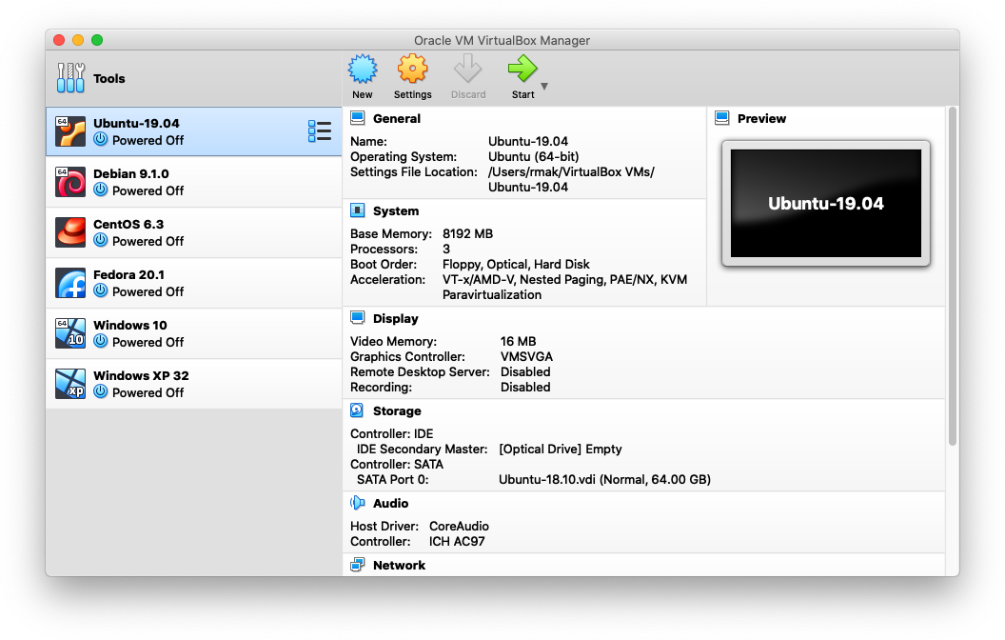

Figure 1. The VirtualBox main screen (running on MacOS X).

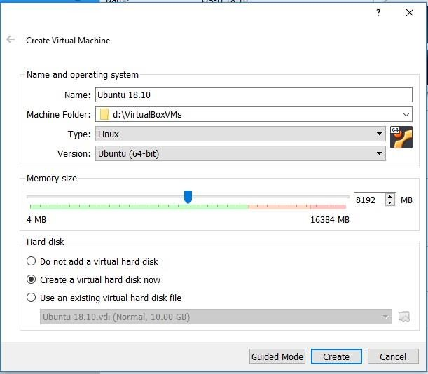Click the *New* button and fill in the **Create Virtual Machine** form (Figure 2). Pick an appropriate name. Choose a machine folder on your laptop that will contain the virtual machine image. The type should be *Linux*, and the version should be *Ubuntu (64 bit).*

Set a memory size for the virtual machine, but don’t give it more than half of the

memory of your host laptop. Select the

*Create a virtual hard disk now* radio button. Click the *Create* button.

Figure 2. The Create Virtual Machine form.

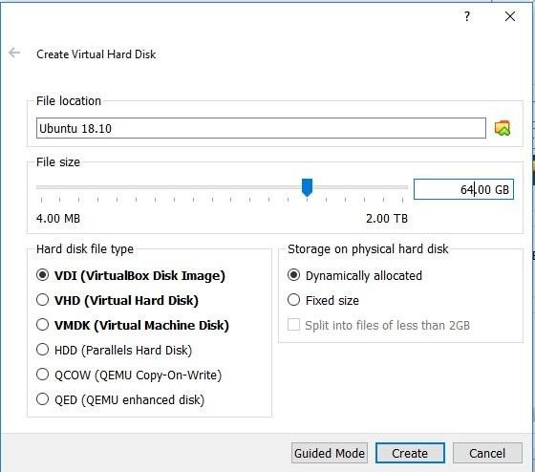On the **Create Virtual Hard Disk** form (Figure 3), specify the maximum size to which

Ubuntu’s virtual hard disk can grow. Select the *VDI (VirtualBox Disk Image)* and *the Dynamically allocated* radio buttons. Click the *Create* button. This creates the new virtual machine named, for example, Ubuntu 18.10

(Figure 4).

**Note:** For an installation of Ubuntu, specify at least **64 GB** for the size of the virtual hard disk.

Figure 3. The Create Virtual Disk form.

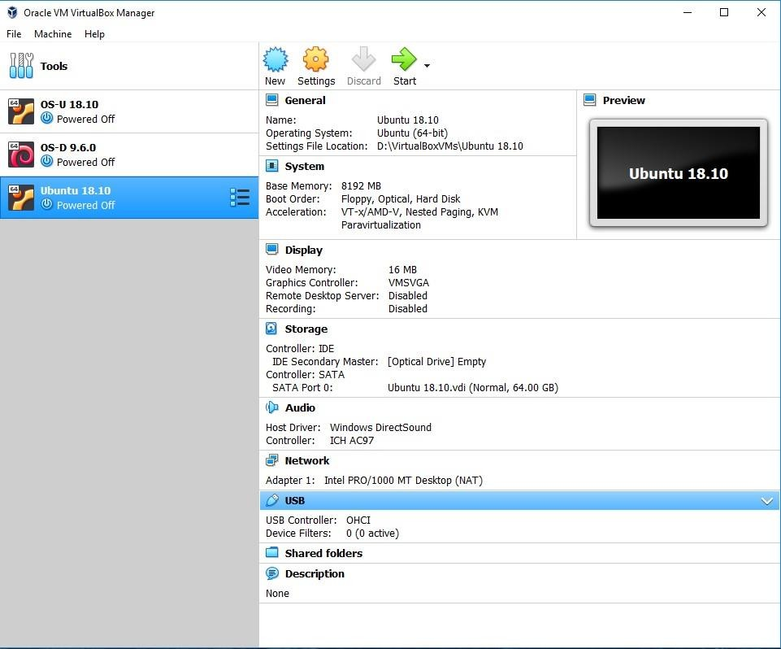

Figure 4. The virtual machine named Ubuntu 18.10 is created.

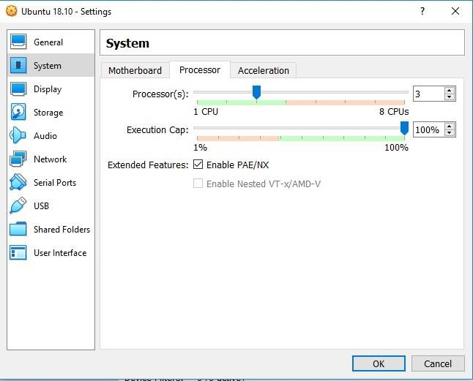Select the name of the newly created virtual machine. Click the *Settings* icon at the top. Then click on *System* in the left panel. In the **System Settings** form, select the *Motherboard* tab. Specify the amount of base memory you want to devote the virtual machine, but not more than half of

the physical memory in your host machine.

Select the *Processor* tab (Figure 5) and

specify the number of CPUs you want to devote to the virtual machine, but not more than half the number of CPUs in your host machine. Click the *OK* button.

Figure 5. The System Settings form.

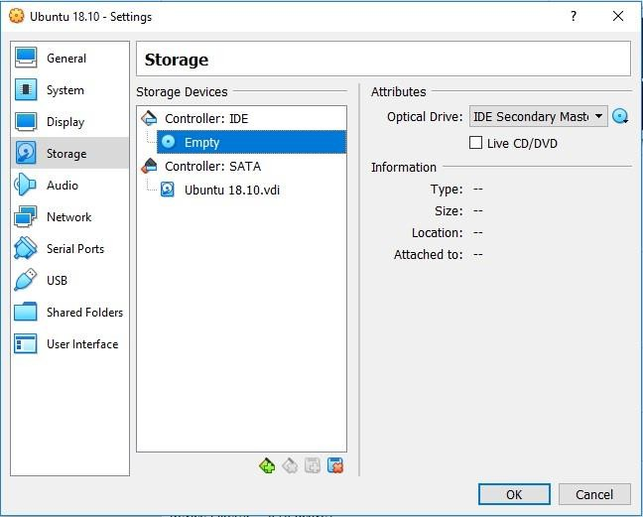**Note:** For an installation of Ubuntu, specify at least **2 CPUs** and **4 GB of memory**. Click *Storage* in the left panel. The **Storage**

**Settings** form (Figure 6) shows the virtual CD ROM drive, which is initially empty, and the virtual hard drive, which is the .vdi

**virtual disk image** that VirtualBox created. Select *Empty* under *Controller: IDE*.

Figure 6. The initial Storage Settings form.

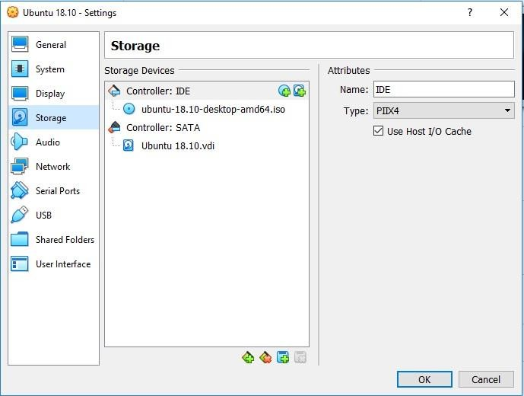You want to install Ubuntu on the virtual machine, so you must

“insert” the .iso installation disk image file that you downloaded earlier into the virtual CD ROM drive. Look under *Attributes* and click on the image of the disk to the right of the dropdown menu.

Select the .iso file to insert into

the drive. You should now see the

.iso file name under *Controller: IDE* (Figure 7). Click the *OK* button.

Figure 7. The installation disk image inserted into the virtual CD ROM drive.

# Install Ubuntu

Now you are ready to start the virtual machine (Figure 8) in order to install Ubuntu. To start the Ubuntu virtual machine, highlight it and click the *Start* button at the top.

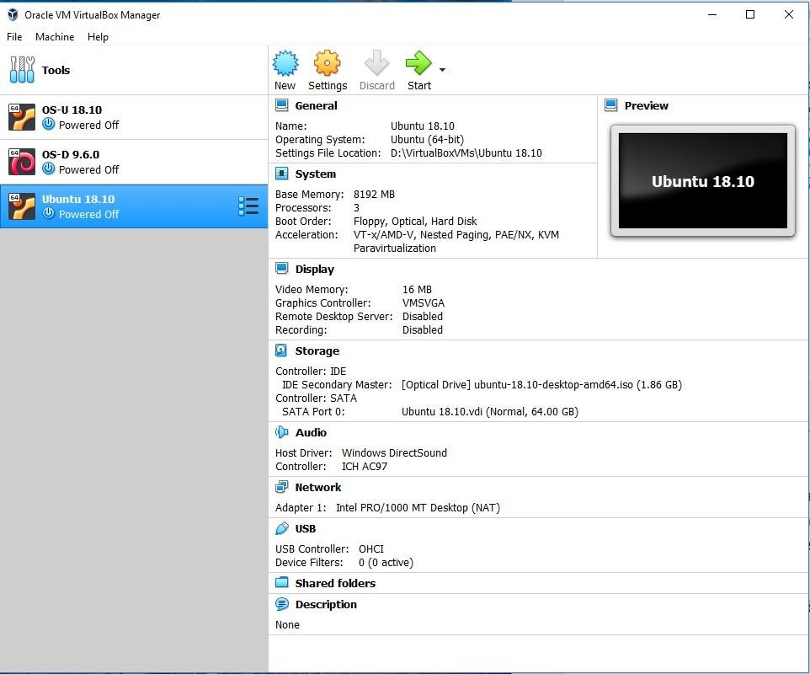

Figure 8. Ready to start the Ubuntu virtual machine.

The virtual machine will boot off the installation disk and start the installation process (Figure 9).

Because the installation process downloads files from the Internet, you will need a good connection.

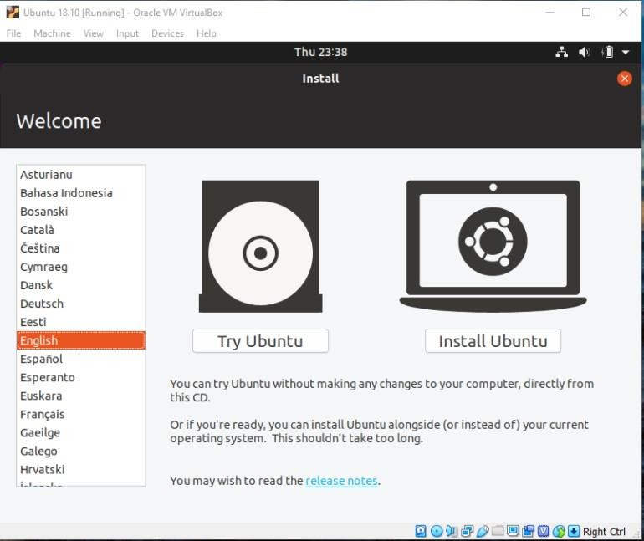Choose your language and click *Install Ubuntu* to start the installation process. At various times, you will be asked to make a choice. Except otherwise directed, you should accept the default choices.

Figure 9. Starting the installation process.

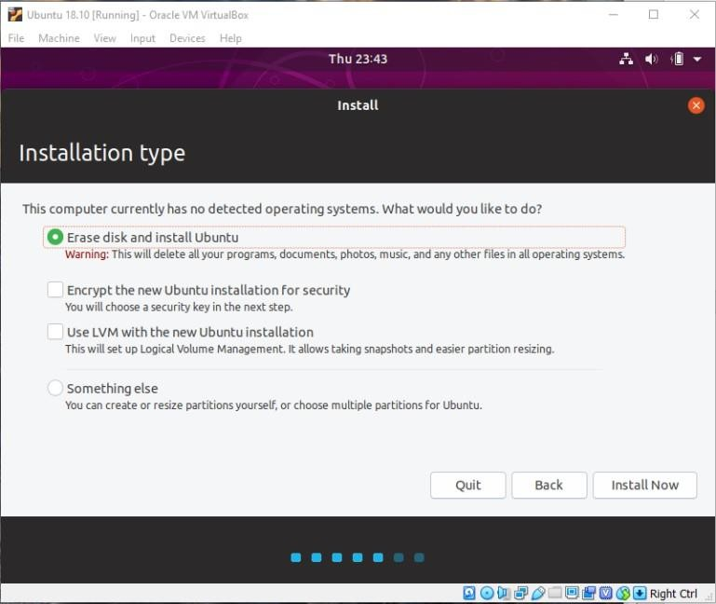On the **Installation type** form, accept the choice *Erase disk and install Ubuntu* (Figure 10). The disk that it will erase is the virtual disk, not your host laptop’s physical disk!

Click the *Install Now* button and the subsequent *Continue* button.

Figure 10. Erase the virtual disk and install Ubuntu.

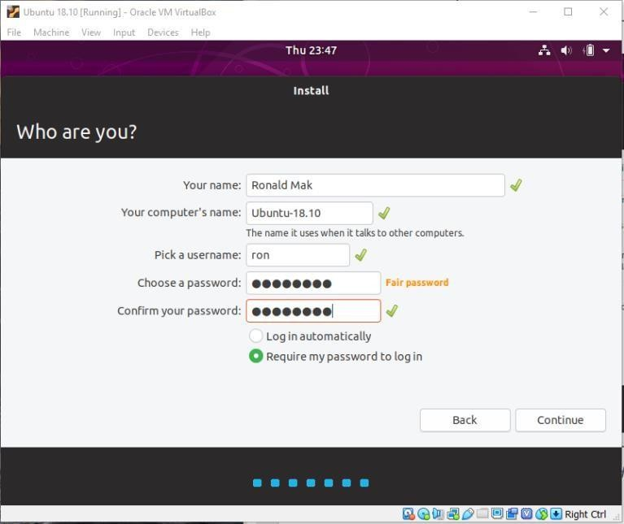On the **Who are you?** form (Figure 11),

enter appropriate names. The username will also become the name of your home

directory in /home. The passwords will become your login passwords.

Figure 11. Choose names and passwords.

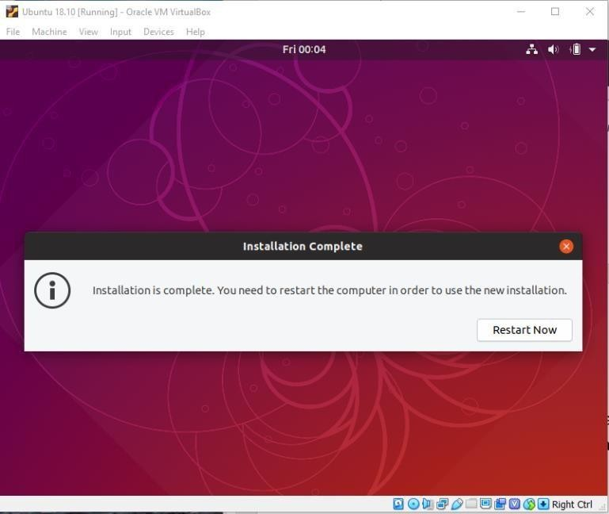The installation process will take a while, especially if you have a slow Internet connection. You can watch files download and install, or you can go have a cup of

coffee. When it’s finally done, it will ask you to restart (Figure 12). Press the *Restart Now* button.

Figure 12. Installation is complete.

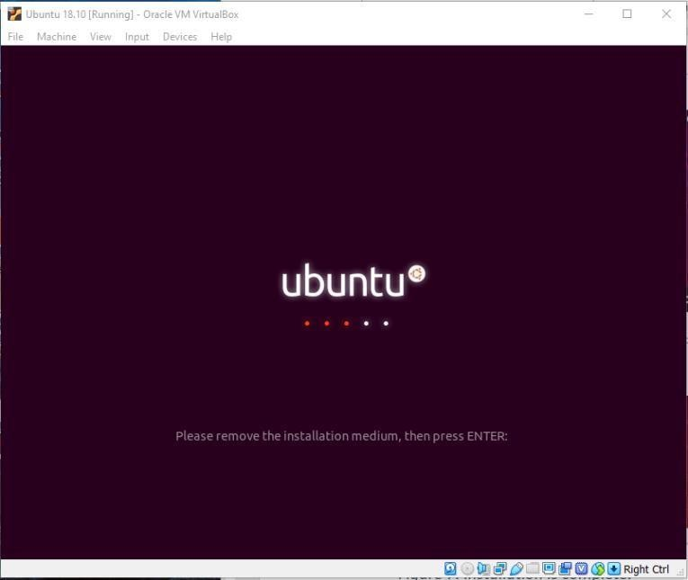Ubuntu will restart and ask you to remove

the installation disk from the virtual CD ROM drive (Figure 13).

Right-click on the image of the CD ROM at

the bottom of the screen and select *Remove disk from virtual drive*. You may need to press the right control key on your keyboard if the virtual machine has “captured” your mouse. After removing the disk, click in the Ubuntu window and press the enter key.

Figure 13. After the initial system restart.

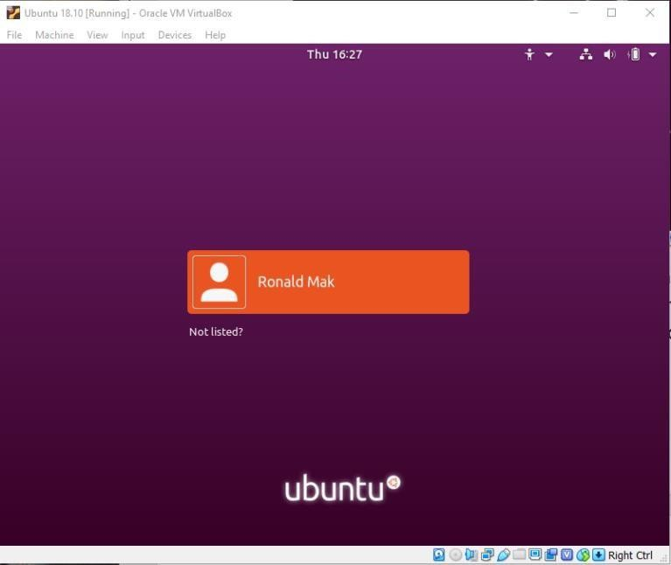After the VirtualBox splash screen and some system startup messages, you will be asked to log in (Figure 14).

Click on your name and enter your password.

Figure 14. The login screen.

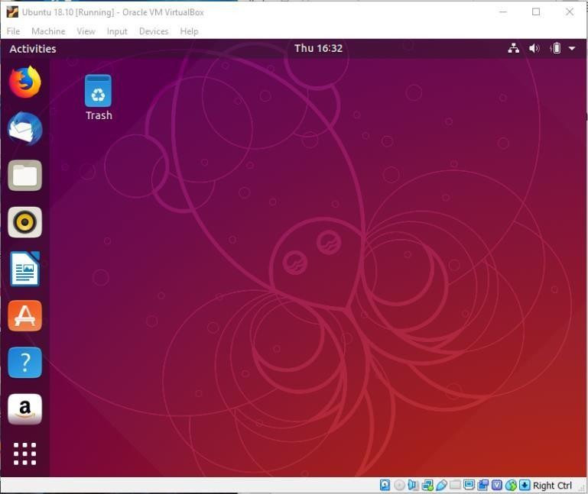You have successfully installed Ubuntu as a virtual machine (Figure 15)!

Figure 15. Ubuntu is successfully installed!

# Open an Ubuntu terminal window

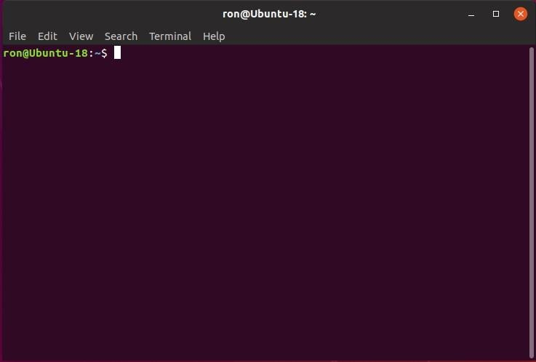Open an Ubuntu terminal window in order to enter and execute commands on the command line. Click the Show Applications

icon (the matrix of nine dots) at the bottom

left of the desktop to display application icons. In the search box at the top, type “terminal”.

The terminal icon appears. Rightclick the icon and select *Add to Favorites* to add a terminal icon to the left panel so that you can easily

open a terminal window in the future. Double- click the terminal icon to open a terminal window (Figure 16).

Figure 16. An Ubuntu terminal window.

# Install guest additions

Guest additions are additional software that you install in the guest operating system (i.e., Ubuntu) that provide important useful features, such as shared folders and the ability to cut and paste between the guest and host environments. Guest additions are fully explained in Chapter 4 of the *VirtualBox User Manual*, which is in the doc directory of the VirtualBox installation on your host machine.

In the top menu bar of the virtual machine window (you may need to hold down the right control key on your host keyboard and press C to make the top menu bar appear), drop down the Devices menu and select *Insert Guest Additions CD image …*.

You can also insert the image manually. Look for the virtual disk image file

**VBoxGuestAdditions.iso** in the top folder of your installation. Right-click the image of the CD ROM at the bottom of the virtual machine window (right-click control-C if necessary to see it) and insert the .iso file.

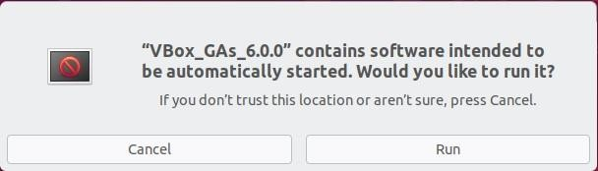A dialog will pop up asking if you want to run automatically started software (Figure 17).

Figure 17. Click the Run button to install the guest additions.

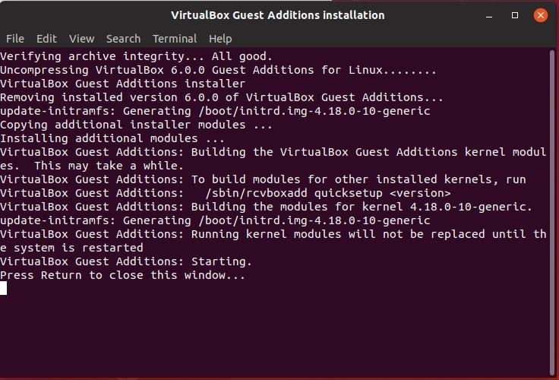Click the *Run* button and the software will install (Figure 18).

Figure 18. Installing the guest additions.

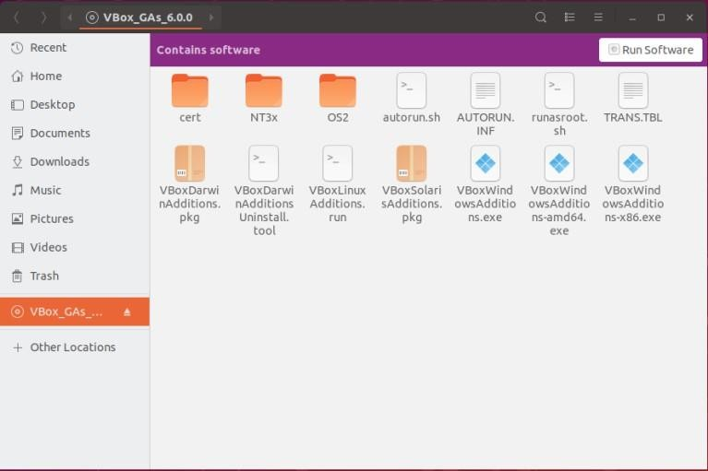You can also start the installation script manually. Click the Vbox_GAS icon in the upper left of the Ubuntu desktop to display the contents of the virtual disk (Figure 19). Click the *Run Software* button in the upper right.

Figure 19. Contents of the guest additions virtual disk.

## Conclusion

The installation of **Ubuntu on VirtualBox** allows you to run a fully functional Linux environment on your existing system without dual-booting or replacing your current OS. This process is highly beneficial for developers, testers, and anyone looking to explore Ubuntu’s features in a virtualized environment.

By following the installation steps—setting up VirtualBox, configuring the virtual machine (VM) settings, installing Ubuntu, and ensuring post-installation configurations—you have successfully created an isolated and easily manageable environment.

This setup provides flexibility, enabling you to experiment with Ubuntu, test software, and learn Linux commands without the risk of affecting your primary system. Furthermore, VirtualBox offers the advantage of taking snapshots, which ensures that you can revert to previous states if needed, adding a layer of safety and convenience to your work.